Bethel Presbyterian church was organized in 1824 under the leadership of Rev. Samuel Hunter, who served as its first pastor for a very short time. The original membership was drawn from the Bayou Pierre Church, which had been organized in 1807 about 3 miles west of Port Gibson. Hunter was pastor of the Bayou Pierre Church at the time, and he brought some of the members with him to establish the new church.

In 1828 Rev. Zebulon Butler began serving as pastor of the Bayou Pierre church. Under his leadership, the congregation moved to Port Gibson, and changed its name to the First Presbyterian Church of Port Gibson.

In 1828 Butler also began serving the Bethel congregation, and the same year the Mississippi Legislature granted a charter to the “Presbyterian Congregation of Bethel” and named William Young, Lewellin Price, John Magruder, and Smith C. Daniell as trustees.

In 1830 a new element of life was introduced into this church by the organization of Oakland College. The first classes were held nearby the congregation’s meeting place, which was between Alcorn State and Rodney

In 1837 Rev. Joshua T. Russell became pastor and served the church until about 1842. It was during his term of service that the congregation moved to this site and built the present house of worship. Located about 2 miles east of Oakland College (now Alcorn State University) at Bethel Cross Roads, the church is situated on 3 ½ acres of ground which was donated by Lewellin Price, grandfather of the late Rev. Robert Price of Southwestern (now Rhodes), on February 18, 1839.

The deed mentions that the land was adjacent to Oakland College. It contains the following condition: “that no house or shop for selling or retailing intoxicating liquors shall be erected on the above described lot or parcel of ground,” and that no “enticements shall be Created of any kind whatsoever thereon calculated to interfere with the studious habits or good order of the students of Oakland College and in case this condition be violated then the said lot or parcel of ground together with the improvements thereon erected shall be forfeited and revert back to my legal heirs.”

In 1843 Rev. John R. Hutchison served in the joint capacity of professor of ancient languages in the college and as pastor of the church. It is not clear as to the length of his pastorate. But in the period just before the “War Between the States,” as well as after, many changes in the community and in the life of the church took place. It appears that Bethel Church became inactive for a number of years.

In 1860, however, we observe the organization of the “Oakland College Church,” whose brief period of life lasted only until about 1871. The Rev. Wm. L. Breckinridge was the pastor during this time.

In 1884 the records show that Bethel Church came back to life again, under the leadership of Rev. George G. Woodbridge who served the church only until 1887.

In 1893 Rev. W.B. Bingham, who evidently served other churches in the surrounding area, became pastor, and served the church until about 1896. Following his pastorate the church seems to have become entirely inactive for a long period of 35 years.

In 1930 however, as a result of the vision and zeal of Rev. T.B. Hay, pastor of the Port Gibson Church, the religious needs and opportunities of the community around Bethel Church were seen and an effort made to meet them. Presbytery was persuaded to place a Home Mission worker in the field, and Miss Marie Gibert was employed.

A Sunday School was organized and the old church once more opened its doors. In this same year Rev. O.G. Jones, Synod’s Superintendent of Home Missions, held a meeting in the church and re-organized it with 28 members. Mr. Jim Beck was made an elder and Mr. Everett Mitchell a Deacon. These two were also appointed Trustees of the property. Rev. T.B. Hay served as pastor until 1931 when he accepted work in Memphis, Tennessee.

From that time, Bethel church was served by whoever had been installed as pastor of the First Presbyterian Church of Port Gibson. On November 6, 1943, during the pastorate of the Rev. A.N. Moffett, a tornado largely destroyed the building. Between October of 1944 and March of 1945 the building was reconstructed. It was rededicated to the Glory of God on Easter Sunday, April 1, of 1945.

Although rebuilt, the building was extensively changed. The pointed steeple and slave gallery were removed, and the wooden floor was replaced with concrete. In addition, the entire structure was shortened – it once had four windows on each side, but now there are only three.

On August 13, 1950, the Rev. William B. Lowrance preached his first sermon at Bethel, to a total of 22 persons. After the service, a roll of members was discussed, and it was discovered that 34 of the reported membership of 58 were all that still resided in the area of the church. Preaching services were established for the second and fourth Sundays of each month.

During those years, the church was loyally supported and encouraged by the families still in the immediate area of the church. Among those active in their encouragement were Mrs. Allie Harrell and her family. Living in the immediate proximity of the church, her daughter (Mrs. W. R. Hammett) kept records and finances for the church, and otherwise cared for the church in Spiritual and physical ways, making herself available as the "contact person" for the various ministers serving the field.

In the Fall of 1962 a repair program achieved some badly needed work both inside and outside the present building. Deacon John H. Bare of the First Presbyterian Church in Port Gibson, devoted considerable time to the work. The Church Extension Committee of South Mississippi Presbytery apportioned $500 for the work. At the completion of this work, a re-dedication service was held with Rev. John Keels, Executive Secretary of the Church Extension Committee, leading the service.

At that time, the presbytery formally declared the Bethel Church to be an "outpost" (Chapel) of the First Presbyterian Church of Port Gibson. This action was taken on the request of the First Church, with the concurrence of the Bethel congregation.

In December of 1962, the Session of the First Presbyterian Church officially transferred 20 members to the First Church active roll (designated Bethel Outpost). Twenty-two members were placed on a 'Bethel retired roll" and eight were marked "deceased". Services continued to be held at Bethel on the second and fourth Sundays until the Fall of 1974. At that time, services were held quarterly until they were finally discontinued.

One of the most active members of Bethel, Mrs. James E. Cassell, daughter of Mrs. W.R. Hammett, passed away in early 1965, and the pulpit furniture was given in her memory.

The congregation of the First Presbyterian Church of Port Gibson continues to oversee the preservation of the building. Worship services are now held at Bethel in the Spring and the Fall.

Our mailing address is:

First Presbyterian Church
P.O. Box 517
Port Gibson, MS 39150

The History of
Bethel Presbyterian Church

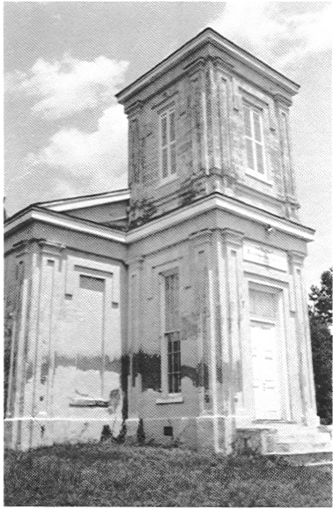

Founded in 1824

